Course Title: Social Immersive Learning
Course Code: 22UC0021
Name: L.Ishitha
Roll No: 2420030041
Section: 10

Title of the Event:
Crack the Code Contest

Organized by:
Department of Computer Science and Engineering, KLH University – Bachupally Campus

Date:
October 14, 2025 | 10:00 AM – 1:00 PM

Event Summary:
The “Crack the Code Contest” was an intensive competitive programming event that tested participants’ problem-solving abilities, algorithmic skills, and coding efficiency under time constraints. Such contests play a crucial role in building computational thinking, analytical reasoning, and logical problem-solving abilities. The event encouraged students to strengthen their knowledge of data structures, algorithms, and optimization techniques while developing the precision and speed required in real-world software development. Success in this competition is a reflection of strong technical foundations and readiness for careers in software engineering and advanced computing fields.

About the Event:
The Crack the Code Contest was organized internally by the Department of Computer Science and Engineering to promote programming excellence among students. Participants were required to solve a set of algorithmic challenges of varying difficulty within a limited time frame. The problems tested proficiency in languages such as Python, C++, and Java, focusing on logic building, data manipulation, and efficiency.
Avadhari Sahithya successfully participated in this event and demonstrated commendable coding and analytical skills throughout the competition. The event provided a valuable platform to apply theoretical programming concepts to real-world scenarios, encouraging participants to think critically and code efficiently.

Key Highlights:
- Multiple rounds featuring algorithmic and data structure-based challenges.
- Focused on problem-solving accuracy, code efficiency, and logical reasoning.
- Exposure to real-time competitive programming environments.
- Encouraged collaborative learning and peer motivation among participants.
- Opportunity to enhance programming confidence and technical expertise.

My Participation:
I participated in the Crack the Code Contest and experienced the thrill of solving time-bound coding challenges. The problems required a deep understanding of algorithms, logical thinking, and debugging strategies. Competing in such a high-pressure environment helped me enhance my focus, efficiency, and analytical reasoning. The event motivated me to continue improving my coding proficiency and to take part in more competitive programming contests in the future.

Event Photographs:
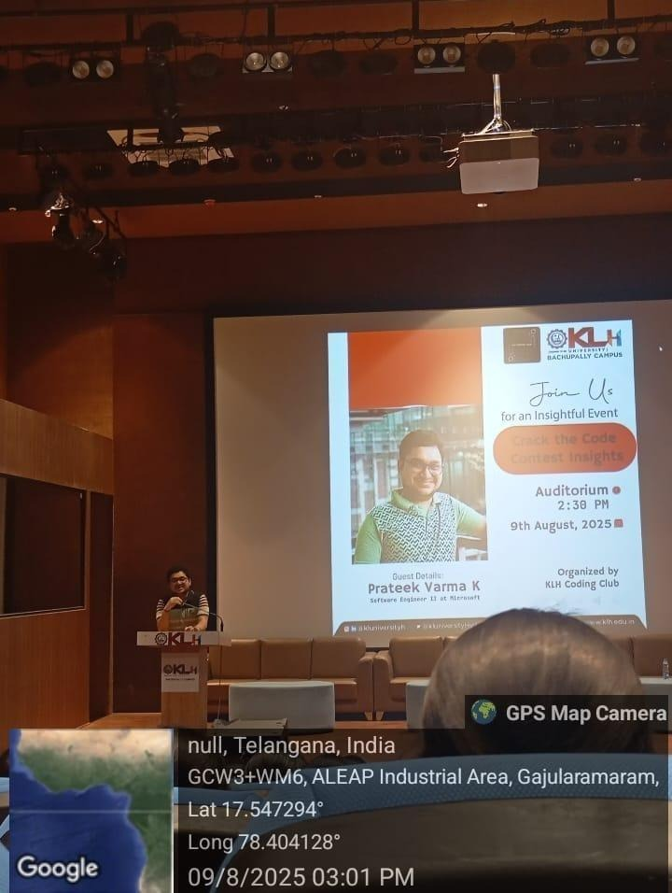

Conclusion:
The Crack the Code Contest was a valuable experience that enhanced my technical competence and problem-solving mindset. It reinforced the importance of continuous learning and practice in programming. Events like these prepare students for the challenges of technical interviews and industry-level problem-solving.

Acknowledgment:
Special thanks to KLH University and the Department of Computer Science and Engineering for organizing this event and providing a platform for students to test and strengthen their coding abilities through practical and competitive challenges.

